**بسم الله الرحمن الرحيم**

KingSaudUniversity

College of Computer & Information Sciences

Computer Science Department

|  |  |
| --- | --- |
| **Tutorial:N**5 |  |
| **Course Title:** Software Engineering | **Course Code:** CSC 342 |
| **Dr. S.Hammami** | **Mr. Mudassar** |

**Exercise :**

Saudi Marketing Company Limited (SAMCO) is one of the leading companies in the field of retail, trading, and importing business in Saudi Arabia. In this company, the advertising project manager has developed a program for a new advertising promotion. During this development, the manager has gathered the time information for each activity, as shown in the table below.

|  |  |  |
| --- | --- | --- |
| **Activity** | **Time**  **(in days)** | **Predecessors** |
| A | 5 | - |
| B | 7 | - |
| C | 6 | - |
| D | 3 | A |
| E | 4 | B,C |
| F | 2 | C |
| G | 6 | A,D |
| H | 5 | E,F |

1. Draw the network activity diagram and find the earliest and the latest start/finish time?
2. Compute the minimum time needed to complete all the activities of the advertising promotion program and identify which activities are critical?
3. If activity E is delayed by 3 days,Will the advertising promotion program completion time be affected? Justify your answer.
4. If activity F is delayed by 3 days,Willthe advertising promotion program completion time be affected?Justify your answer.

**Solution:**

1. The network activity diagram and the earliest/latest start/finish time are shown in the diagram belowwith format of for the earliest/latest start/finish time.

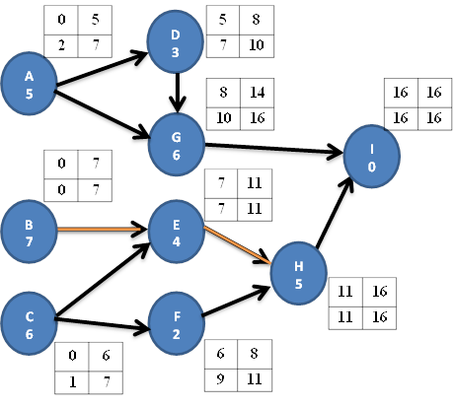

Note: A dummy activity I with duration of zero is used here to represent the end of the program'sactivities.

1. The minimum time needed to complete all the activities of the advertising promotion program is 16 days and the critical activities are B, E, H and I because the amount of slack equal zeros.
2. Yes, the program completion time will be affected because the activity E is part of the critical path and has a slack of zero days.It must be done on time. So, if 3. If activity E is delayed by 3 days, the program completion time increases by exactly 3 days.
3. No, the program completion time will not be affected because the activity F is not part of the critical path and has a slack of 3 days.